Prelab 3

Dario Rendon

1. Pulse-width modulation (PWM) is a modulation technique that transforms the width of a pulse, based on the modulator signal information.  
     
   A duty cycle describes the proportion of “ON” time versus “OFF” time over the period of the cycle.
2. 3%  
   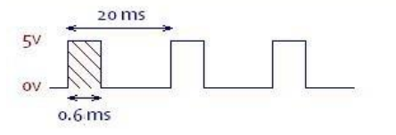  
   12%  
   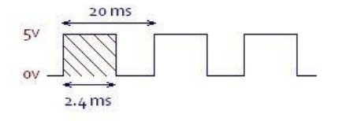
3. */*  
    * Converts an angle to a PWM interval in microseconds  
    * @param angle The angle 0 to 180 for the servo motor to turn to  
    * @return PWM interval in microseconds  
    */***int** degreeToOnDelay(**int** angle) {  
    **return** (angle * 10) + 600;  
   }
4. 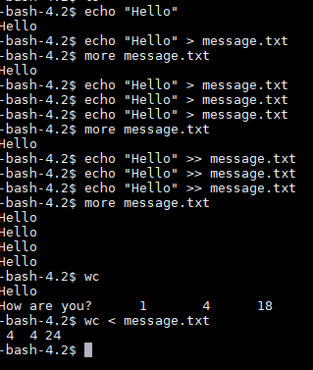

> in 3.5 is used to set the GPIO configurations and then send the output from setting the configuration to /dev/null which discards the output